Part I 80 Marks

Record your answers to Questions 1–40 on the separate Multiple-Choice Answer Sheet using a blue or black pen or a B or 2B pencil. If you make an error, follow the instructions given to you on the answer sheet.

Select the single correct alternative in each of the following questions.

Questions 1 and 2 refer to the following graph.

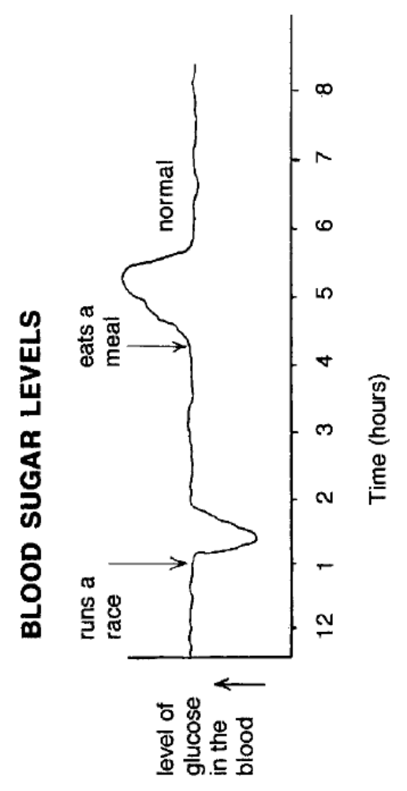
12.001.002.003.004.005.006.007.008.00
level of glucose in the blood
Blood sugar levels
Time (pm)
starts a race
eats a meal
normal

1. The blood glucose levels recorded in the graph show the changes in a person with normal endocrine function.

Which hormone is causing the change in glucose levels between 5.15pm and 5.45pm?

(a) insulin
(b) glucagon
(c) adrenalin
(d) glycogen

2. At the start of the race

(a) glucagon causes the liver to increase the release of glycogen into the blood for transport to muscle cells.
(b) insulin causes increased glucose uptake by muscle cells for use in respiration to release energy.
(c) adrenalin causes the release of glucose from muscle cells into the blood.
(d) glucagon causes increased glucose uptake by muscle cells to be stored as glycogen.

3. Soon after a meal rich in carbohydrates, the concentration of glucose in the blood vessels leading to and from the liver was measured. Which one of the following is correct?

(a) The glucose content of the blood entering and leaving the liver would be much greater than normal.
(b) The glucose content of blood entering the liver would be much greater than normal, while that leaving the liver would be slightly higher than normal.
(c) The glucose content of the blood entering the liver would be higher than normal and the blood leaving the liver would contain much less glucose than normal.
(d) The glucose content of the blood entering and leaving the liver would remain fairly constant and would not be affected by the meal of carbohydrates.

4. Which one of the following is not a function of the liver?

(a) excretion of urea
(b) deamination of proteins
(c) regulation of blood sugar
(d) source of metabolic heat

5. Which one of the following is an incorrect statement for the functioning of the kidney?

(a) It removes excess fluids from the body.
(b) It actively reabsorbs glucose from the filtrate.
(c) It excretes toxic products of metabolism.
(d) It eliminates excess amino acids from the body.

6. The connective tissue membranes that surround the brain protect it from shock and contain blood vessels that supply nutrients and oxygen to the underlying brain tissue. These membranes are called

(a) meninges.
(b) cerebrospinal membranes.
(c) grey matter.
(d) cranium.

7. The two parts of the eye that affect the focus of light rays onto the retina are the

(a) lens and fovea.
(b) lens and cornea.
(c) fovea and iris.
(d) cornea and iris.

8. Blood does not usually come into contact with the cells it supplies. Exchange of nutrients and wastes between the blood and the cells occurs through

(a) capillary networks.
(b) lymphatic vessels.
(c) extracellular fluid.
(d) intracellular fluid.
9. The movement of water from the loop of Henle in the nephron to the surrounding renal blood vessels is by

(a) osmosis.
(b) diffusion.
(c) active transport.
(d) filtration.

10. Refer to the following graph, which shows the changes in body temperature of a human during the first 120 hours of a bacterial infection.

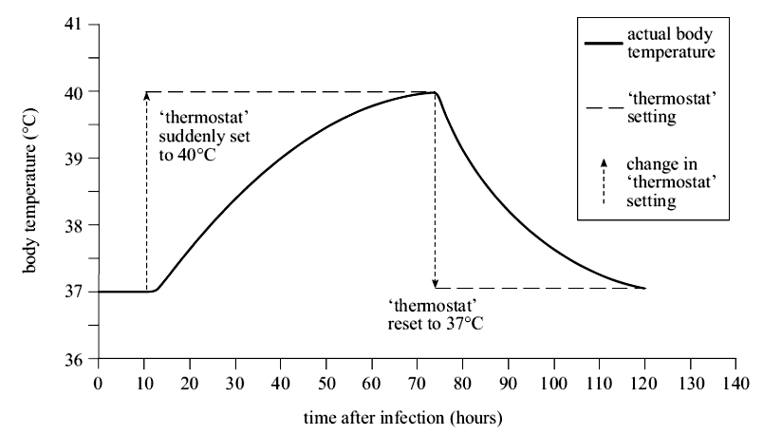
actual body temperature
‘thermostat’ setting
change in ‘thermostat’ setting
‘thermostat’ reset to 37EC
‘thermostat’ suddenly set to 40EC
Time after infection (hours)
Body temperature (EC)
0102030405060708090100110120130140
41

40

39

38

37

36

During a bacterial infection, white blood cells release a protein that changes the set point of the brain ‘thermostat’ from 37°C to 40°C. When this protein breaks down after about 3 days, the brain ‘thermostat’ is reset to 37°C.

Which one of the following responses is most likely to occur?

(a) a decrease in thyroxine production between 10 and 70 hours after the onset of the infection
(b) shivering 40 hours after the onset of the infection, when the body temperature is about 39°C
(c) a decrease in metabolic activity between 10 and 70 hours after the onset of the infection
(d) a decrease in sweating 80 hours after the onset of the infection, when the body temperature is about 39°C
11. Several people from whom the thyroid gland had been removed because of throat cancer were tested for the effects of hormones involved with the thyroid gland. Four separate groups were established, each receiving different treatments.

Group 1 Injection of saline solution containing no hormones (placebo).
Group 2 Injection of TSH.
Group 3 Injection of TSH releasing factor.
Group 4 Injection of thyroxine.

Which one of these groups would show the symptoms of hypothyroidism?

(a) Groups 2, 3, and 4
(b) Group 1 only
(c) Groups 1, 2 and 3
(d) Group 4 only

12. Which one of the following statements matches the hormonal imbalance with its symptom?

(a) High levels of testosterone lead to infertility in males.
(b) Low levels of human growth hormone in children cause dwarfism.
(c) Low levels of ACTH cause water retention.
(d) High levels of oxytocin cause ovulation.

13. Smoking tobacco reduces the amount of oxygen carried by the blood. This is because

(a) tar from smoke builds up on the lining of blood vessels, reducing blood flow.
(b) smoking causes cancer of the blood, reducing the number of red blood cells.
(c) smoke contains carbon dioxide, which breaks down red blood cells.
(d) smoke contains carbon monoxide, which combines with haemoglobin.

14. The eye defect that causes light from an object close to the eye to be focused behind the retina is called

(a) presbyopia.
(b) hypermetropia.
(c) astigmatism.
(d) myopia.

15. Which one of the following will result in an increased breathing rate?

(a) increased oxygen levels detected by the hypothalamus
(b) decreased carbon dioxide levels detected by the hypothalamus
(c) stimulation of the chemoreceptors by increased carbon dioxide
(d) stimulation of the sympathetic nerves in the lungs

16. As urine passes through the ureters, bladder and urethra of humans

(a) its contents are unchanged.
(b) excess water is reabsorbed.
(c) excess urea is actively secreted.
(d) its concentration is increased.
17. Walking quickly around a corner, you nearly run into someone standing in the corridor. Your heart rate increases and your pupils dilate. Which branch of the nervous system has been activated?

(a) central
(b) somatic
(c) parasympathetic
(d) sympathetic

18. Antibiotics are often not effective against viruses because viruses

(a) keep changing their external protein coat.
(b) are able to disguise themselves in the host cell membrane.
(c) are not true living cells, so their metabolism is not affected by antibiotics.
(d) can destroy or inhibit the actions of antibiotics in living cells.

19. HIV is difficult for the body’s immune system to fight because

(a) it infects helper T cells, which then die, reducing the specific response to the virus.
(b) phagocytes do not recognise the virus when it enters the internal environment.
(c) it causes many different conditions according to the tissue it has infected.
(d) the virus can lay dormant for many years without causing any symptoms.

Question 20 refers to the diagram of skulls below.
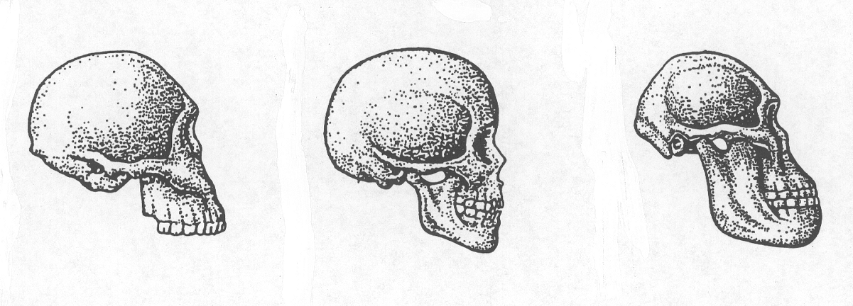
Skull A Skull B Skull C

(Note: These diagrams are not drawn to scale.)

20. Which statement about the skulls shown above is true?

(a) All of the skulls are from hominins living in the present.
(b) All the skulls would have been fossil finds from similar sites.
(c) The skulls show the evolutionary trend for cranial size, left to right.
(d) Skulls A to C indicate the evolutionary sequence from youngest to oldest.
21. A great number of fossil finds have been made in sedimentary rocks formed underwater, either in lakes or on the seabed. This is because

(a) more life existed in the oceans in prehistoric times.
(b) organisms that live in water have easily fossilised parts.
(c) organisms do not live where rocks are formed on land.
(d) remains of organisms are more likely to be covered with sediments.

22. Which one of the following statements would not have been made by Darwin in support of natural selection?

(a) Members of the same species show variation in phenotype.
(b) Some characteristics are heritable and passed on to offspring.
(c) Members of different species show some similarities in phenotype.
(d) Some characteristics are associated with a better chance of survival.

23. A man with blood group AB has a child with a woman with blood group O. What is the probability of the child having the blood group A?

(a) 100%
(b) 50%
(c) 25%
(d) 0%

24. The forms of cave art shown below are representative of which group of human ancestors?

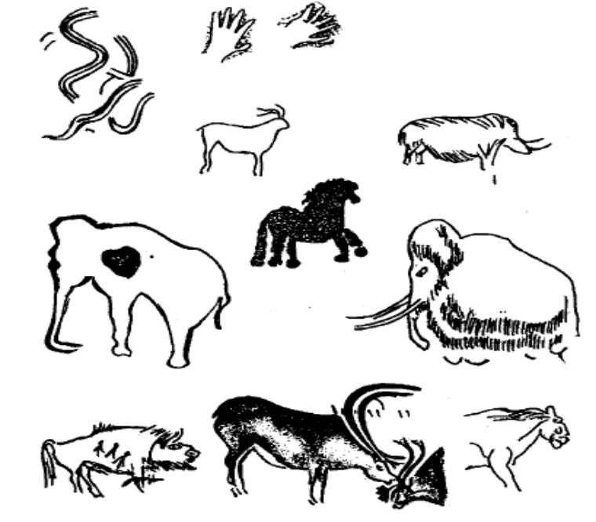

(a) Neanderthals
(b) Homo erectus
(c) Homo habilis
(d) Cro-Magnons
25. The estimated life expectancy of Cro-Magnon Man was about 32 years. In the fourteenth century, people living in England had a life expectancy of about 38 years. In Australia today, life expectancy is around 80 years. The lengthening of the human life span is mainly a result of

(a) natural selection.
(b) climatic changes.
(c) absence of diseases.
(d) cultural changes.

26. In many respects, Australian Aborigines were the most successful hunter-gatherers in all human history. To be successful hunter-gatherers, the Aborigines

(a) abandoned artistic and religious practices.
(b) did not stay in one place for very long.
(c) lived in large groups containing many families.
(d) stockpiled food for times of drought.

27. Which one of the following would not have made a contribution to the Neolithic (agricultural) Revolution?

(a) the development of a writing using symbols of clay tablets
(b) the availability of suitable plant species for cultivation
(c) the development of tools suitable for different purposes
(d) the evolution of culture relating to the division of labour and cooperation

28. The agricultural revolution increased the rate of human cultural change because it

(a) occurred at several different places in the world.
(b) increased the variety of uses of the available land.
(c) caused an increase in the world population.
(d) was a more efficient way of producing food than hunting and gathering.

29. Artefacts differ from fossils in that artefacts

(a) are found associated with human remains.
(b) are made of organic material that can be carbon dated.
(c) are objects produced by hominins for a particular purpose.
(d) are works of art with religious significance.

30. In January 2007, the population of Country X was 20 million. During 2007,
100 000 babies were born. The birth rate for Country X was

(a) 0.05 per thousand.
(b) 0.5 per thousand.
(c) 5 per thousand.
(d) 10 per thousand.
31. Which one of the following is not a renewable source of energy?

(a) solar energy
(b) nuclear energy
(c) biofuels
(d) wind energy

32. Which hormone is responsible for maintaining the levels of calcium in the blood?

(a) ACTH
(b) cortisol
(c) parathormone
(d) progesterone

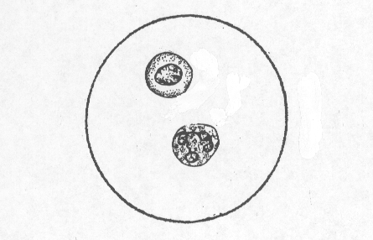
33. Cells shown in the diagram below were observed using a microscope fitted with a 40X objective lens and a 10X ocular (eyepiece) lens. Given that the field of view for this microscope at a magnification of 100X is 200 micrometres, what is the approximate size of these cells?

(a) 10 micrometres
(b) 25 micrometres
(c) 50 micrometres
(d) 100 micrometres

34. Which one of the following combinations of lenses in a light microscope would produce the largest field of view?

(a) eyepiece x15; objective x15
(b) eyepiece x20; objective x10
(c) eyepiece x10; objective x15
(d) eyepiece x5; objective x10
35. While monitoring the growth of bacteria, a researcher noticed that the area around a fungal colony was clear of bacteria. The researcher suggested that this was due to the fungus producing a chemical that killed the bacteria.

The process involved in tentatively relating cause and effect from an observation is best described as

(a) making a generalisation.
(b) reaching a conclusion.
(c) making a hypothesis.
(d) developing a theory.

36. The bacterial population in a liquid culture medium was recorded over a period of
24 hours. Air was pumped through the medium to keep it aerated and it was placed under constant artificial light. The graph below shows the results.

0 6 12 18 24
Time (hours)
Number of
bacteria

The greatest rate of increase in the number of bacteria in the culture occurred between

- 0 and 6 hours.
- 6 and 12 hours.
- 12 and 18 hours.
- 18 and 24 hours.

37. One type of baldness in humans is determined by an allele that, in males, is dominant over the allele for normal hair growth. In females, the same allele is recessive to the allele for normal hair growth.

Which one of the following would be correct for this type of baldness?

(a) A daughter of a bald father and a bald mother could have normal hair growth.
(b) A son of a bald mother and a normal father would have a 50 per cent chance of being bald.
(c) All daughters of bald mothers will be bald.
(d) All sons of bald fathers will be bald.
38. Which one of the following would be the most accurate for determining the frequency of a particular genetic trait in the Australian population?

(a) Determine the percentage of people with the trait in your human biology class, given that the class contains people from diverse backgrounds.
(b) Count the numbers with that particular trait who catch the city-bound train in the morning.
(c) Calculate the percentage of a random sample of people chosen from across the Australian population.
(d) Find the percentage of people from an isolated town and assume it represents the Australian population.

39. An important benefit of sexual reproduction in natural selection is that

(a) it provides for a mechanism for genetic recombination, producing variations in offspring.
(b) it requires less energy than asexual reproduction so the organisms survive and reproduce at a greater rate.
(c) the offspring survival rate is greater than for asexual reproduction.
(d) the offspring require the same conditions for survival as the parents.

40. Which one of the following would help distinguish between autosomal dominant and autosomal recessive inheritance?

(a) the ratio of affected to non-affected individuals in each generation
(b) the occurrence of affected individuals in each generation
(c) the appearance of the effect on individuals later in life
(d) the sex ratio of affected individuals

End of Part I
Part II 80 Marks

Write answers to all questions on the ruled lines after each question or in the spaces provided within each table. Write your answers in blue or black pen.

Question 41 (8 marks)

Refer to the following diagram of the ear for this question.
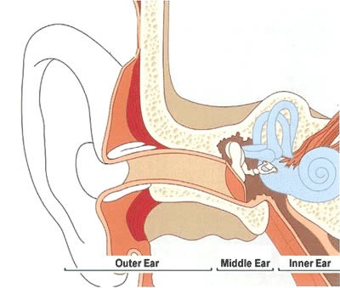
E
D
C
F
A
B

(a) Using the letters given, identify and name the structure in the diagram above that is important in maintaining suitable pressure in the middle ear. (1 mark)

(b) Describe the transfer of sound waves from F through to the sound receptors in C.
(3 marks)

Question 41 (continued)

(c) Explain how structure B allows people to know how their head is moving.
(2 marks)

(d) Picture A below shows the damage caused by high doses of a particular antibiotic on the hair cells in the organ of Corti.

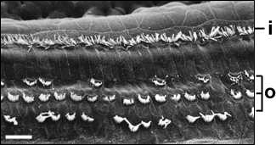
A. Damaged hair cells in the organ of Corti

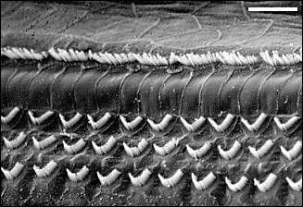
B. Normal hair cells in the organ of Corti

What hearing defects could be experienced by a person as a result of this treatment with antibiotics?
(2 marks)

Question 42 (11 marks)

(a) Alkaptonuria is a condition that causes urine to turn brown/black on contact with air, especially when left for a period of time. It is a rare condition, affecting 1 in 250 000 to
1 million in the population worldwide. It is more common in isolated, mountainous areas of Slovakia in eastern Europe, where about 1 in 19 000 in the population is affected.

Explain why the incidence would be higher in a particular area of Slovakia.
(2 marks)

(b) The pedigree below shows the individuals in a family who show the symptoms of alkaptonuria.
I

II

III

IV
1 2
1 2 3 4 5
1 2 3 4

1

(i) Is this condition controlled by a dominant or recessive allele? Describe two pieces of evidence from the pedigree above to support your answer.
(3 marks)

(ii) What is the probability of II 3 carrying an alkaptonuria allele? Show your working.
(3 marks)

(c) Refer to the following family tree for this question.

1 2
1 2 3 4 5 6
1 2 3 4 5 6 7
I
II
III

Could this family tree show the inheritance pattern for Duchenne muscular dystrophy? Use evidence from the family tree to support your answer.
(3 marks)

Question 43 (4 marks)

Drugs appear to be increasingly available to young adolescents. Before indulging in drug-taking, it would be sensible to think of the biological and social effects of different drugs.

(a) What are two short-term biological effects of alcohol use? (2 marks)
1.
2.

(b) What are two social effects of long-term heroin use? (2 marks)
1.
2.

Question 44 (6 marks)

Refer to the following diagram and graph on the next page.

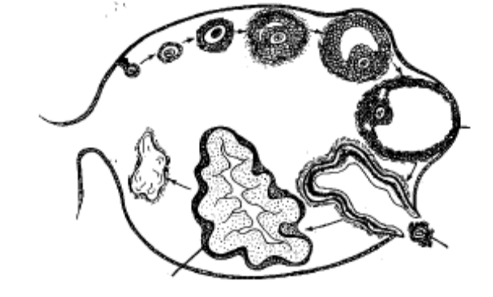
Z
Y
X

Schematic view of ovarian cycle

(a) Name

(i) which of the above structures becomes a temporary endocrine gland.

(ii) what hormone(s) are produced by the temporary endocrine gland.

(2 marks)

Question 44 (continued)

The graph below shows the daily concentrations of 4 different hormones obtained from a woman. Day 0 refers to the day she started her blood tests.

Hormone concentration in blood
Time in days
Follicle Stimulating Hormone (FSH)
Luteinizing Hormone (LH)
Progesterone
Oestrogen
A
B
C
D
0
2
4
10
8
6
12
14
16
18
20
22
24
26
28
30

(b) Which point on the graph represents the same event indicated by Y on the diagram on the previous page?
(1 mark)

(c) State the relationship between FSH and LH in the graph.
(1 mark)

(d) The contraceptive called the ‘mini pill’ contains only the hormone progesterone. Suggest how taking this hormone on a daily basis controls fertility.
(2 marks)

Question 45 (10 marks)

Researchers wanted to observe and record changes in urine volumes in response to drinking different solutions. One person volunteered to drink one litre (1 L) of distilled water that contained no salts. Another person volunteered to drink a saline solution that had the same salt concentration as the body fluids (0.96% salt). Urine volumes were collected every 30 minutes for both the volunteers, starting 30 minutes before they drank the solutions.

Time (minutes) | Urine Volumes  (mL)
 | Person 1  0% salt solution | Person 2  0.96% salt solution
-30 | 55 | 50
0 | 40 | 35
30 | 345 | 55
60 | 410 | 90
90 | 205 | 45
120 | 60 | 95
150 | 85 | 105
180 | 60 | 95
210 | 45 | 55
240 | 55 | 45

(a) Graph these results on the grid provided below. (5 marks)

Question 45 (continued)

(b) Why were recordings made prior to Person 1 and Person 2 drinking the solutions?
(2 marks)

(c) State one factor that is changed in the internal environment as a result of drinking 1 L of 0% salt solution.
(1 mark)

(d) At what time would the blood concentration of ADH be the lowest for Person 1? Explain your answer.
(2 marks)

Question 46 (8 marks)

Refer to the following diagrams showing the parts of a neurone and some components of a reflex arc.

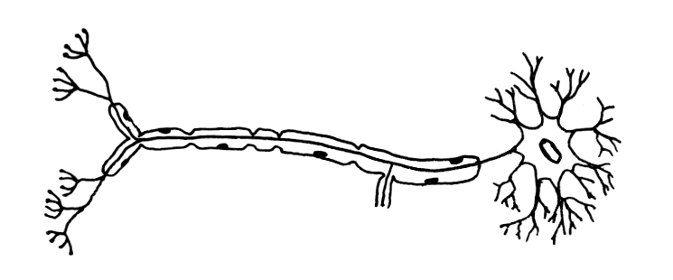
A
B

(a) Identify the structures labelled A and B in the diagram of the neurone above.
(2 marks)
A:
B:

(b) Which neurone in the reflex arc in the diagram below is of the type shown above?
(1 mark)

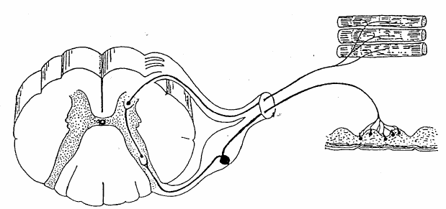
Muscle
Neurone X
Spinal cord
Synapse A
Synapse B
Skin
Neurone Y

Question 46 (continued)

(c) (i) The blue-ringed octopus, which is common on shallow inshore reefs along the coastal beaches and offshore islands of south-west Western Australia, produces a toxin that blocks nerve transmission at some synapses. A person who was revived after being stung by a blue-ringed octopus said he was consciously aware of all efforts of the rescuers when they were doing CPR, but that he could not respond to any of their questions.

Which synapse, A or B, shown in the diagram of a reflex arc would be blocked by the toxin? Explain your answer.
(1 mark)

(ii) Give two reasons to explain your choice of synapse.
(2 marks)

(d) In Hansen’s disease (leprosy) nerve endings in the skin degenerate. Sufferers of Hansen’s disease often do not realise they have been cut or burned. Explain why.
(2 marks)

Question 47 (8 marks)

A study of indigenous human populations in various parts of the world prior to the start of European exploration in the 15th century shows particular trends in height/weight ratios and skin colours.

Change in height/weight ratio with distance from the equator
high

Height/weight
ratio

low
AB
Increasing distance from the equator
Equator
•

(a) What is the most likely body shape (somatotype) of a person living at location A?
(1 mark)

(b) What is an advantage of having a low height/weight ratio when living at location B?
(1 mark)

Skin colour shows a similar trend with geographical distribution.

Change in skin colour with distance from the equator
AB
Increasing distance from the equator
dark

Skin
colour

light
Equator
•

Question 47 (continued)

(c) What is the advantage of the typical skin colour for indigenous people living at A?
(1 mark)

(d) A lack of vitamin D is common among people originally from locations such as A who move to locations such as B. Why does this happen?
(2 marks)

(e) Colonisation of equatorial areas by Europeans occurred after the 15th century. Most of the local indigenous populations decreased dramatically during the first few years of contact with the European settlers.

Give one possible reason for the decline of local populations.
(1 mark)

(f) After colonisation, the indigenous population of countries such as Australia, gradually lost its nomadic lifestyle.

Suggest two reasons why this occurred.
(2 marks)

Question 48 (9 marks)

Refer to the following diagram showing the location of major endocrine organs of the body for this question.

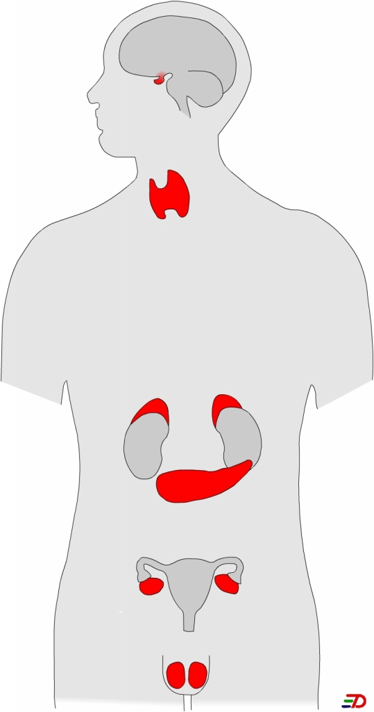
F
B
C
E
D
A

(a) Identify the endocrine glands labelled B and F in the diagram above.
(2 marks)
B:
F:

(b) Adrenal glands (C) have two distinct parts, the medulla and the cortex. State one hormone produced by each part.
(2 marks)

 | Adrenal medulla | Adrenal cortex
Hormone produced

(c) Name one hormone produced by the anterior pituitary that influences the fertility of males and females.
(1 mark)

(d) State two ways in which hormones affect target cells.
(2 marks)

(e) Some athletes take anabolic steroids, such as testosterone, to improve their performance. This practice has been banned by the International Olympic Committee.
What are two changes to the body that occur as a result of taking steroids?
(2 marks)

Question 49 (8 marks)

The following phylogenetic trees portray the relationships between different evolutionary groups suggested by two different anthropologists.

present
H. sapiens
A. afarensis
H. erectus
H. erectus
H. ergaster
H. habilis
H. habilis
A. robustus
A. robustus
A. boisei
A. boisei
A. aethiopicus
A. africanus
A. africanus
A. afarensis
H. sapiens
Johanson-White model
Wood
model

1 million years

2 million years

3 million years

(a) According to the two models, how many fossil species existed 2 million years ago?
(1 mark)

(b) For these two models, what is the difference in the importance of A. africanus in the evolution of modern humans?
(2 marks)

Question 49 (continued)

(c) H. erectus is shown as a direct ancestor of H. sapiens in the Johanson-White model, but not the Wood model. What fossil evidence would support the Wood model?

(2 marks)

(d) Both models have the Australopithecus and Homo groups present at the same geological time. What three features of the fossils would distinguish them as Australopithecus or Homo?
(3 marks)

Question 50 (8 marks)

The drawings below show different sets of tools found at different archaeological sites associated with different human evolutionary groups.
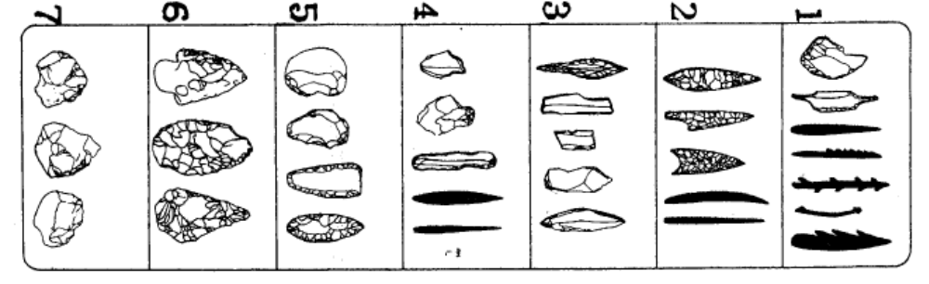
Set 1Set 2Set 3Set 4Set 5Set 6Set 7

(a) Which set of tools is the oldest? Explain your choice.
(2 marks)

(b) What does Set 4 indicate about the uses of different tools?
(2 marks)

(c) What trends in tool development are shown from Set 2 to Set 6?
(2 marks)

Question 50 (continued)

(d) What dating method could be used directly on some tools in Set 7 but not in Set 1? Explain your answer.
(2 marks)

End of Part II
Part III 40 Marks

Answer one question from Section A and one question from Section B. Illustrate your answers with diagrams where appropriate. Up to two marks may be deducted for poorly structured answers: that is, answers in point form or diagrams that are not explained in the text of your answers. Do not write answers in pencil. Write your answers on the lined pages in your Question/Answer Booklet following the end of the questions.

Section A

Answer either Question 51 or Question 52 – not both

Question 51 (20 marks)

(a) Describe four mechanisms of transmission of infectious diseases by bacteria. Give one example of a bacterial infection for each mechanism.
(8 marks)

(b) Explain four of the body’s external defences against infection by bacteria.
(4 marks)

(c) Explain the response of the immune system to a bacterial infection.
(8 marks)

or

Question 52 (20 marks)

(a) Explain the functions of each component of the steady-state control system in maintaining the internal environment within narrow tolerance limits.
(8 marks)

(b) Explain how different body systems work together to maintain the temperature of the internal environment within particular tolerance limits.
(12 marks)

Section B

Answer either Question 53 or Question 54 – not both

Question 53 (20 marks)

(a) Explain why evidence of the existence of some organisms is found in the fossil record and why there is no evidence of others.
(8 marks)

(b) Describe and explain two techniques of relative dating used to analyse fossil finds. Outline the limitations of these techniques.
(8 marks)

(c) Researchers differ in their interpretation of fossil finds. Explain the factors that influence their interpretation.
(4 marks)

or

Question 54 (20 marks)

(a) The profiles below indicate the age structure of two different populations. Use profiles A and B to explain the factors that influence demographic transition.
(8 marks)

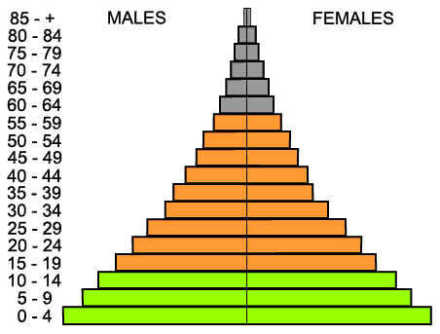
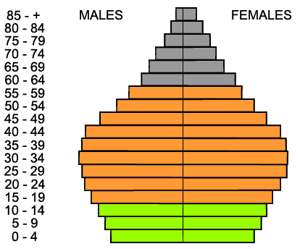
A
B

(b) Explain the impact of increasing human population on two of the following:

- global warming
- global energy availability
- water supply and quality
(12 marks)

End of questions

Check that you have written your Student Number on the front cover of this booklet.

ACKNOWLEDGEMENTS

Question 10 Senior Secondary Assessment Board of South Australia. (2006). Biology external examination. Retrieved June 16, 2008, from http://www.ssabsa.sa.edu.au/docs/ex-2006/2bio-ex-2006-bk12.pdf, p.8.

Question 33 Figure adapted from: Becket, B.S. (1988). Illustrated human and social biology. Oxford: Oxford University Press, Fig. 2, p.59.

Question 36 Australian Council for Educational Research. (1978). Science item bank: Book 3 biology. Melbourne: ACER. Item 732003 751.

Question 38 Australian Council for Educational Research. (1978). Science item bank: Book 3 biology. Melbourne: ACER. Item 744001 30.

Question 41 Figure from: Sussex Audiology Centre. (n.d.) Hearing Loss. Retrieved May 18, 2008, from http://www.sussexaudiologycentre.co.uk/hearing_loss.asp

Question 41(d) Figures from: Lenoir, M. (2007). Pathology of hair cells and neurones: Aminoglycoside ototoxicity. Retrieved May 25, 2008, from http://www.iurc.montp.inserm.fr/cric51/audition/english/pathology/amino/amino.htm

Question 48 Figure from: Ministry of Education (Singapore). (2006). Biology: Endocrine System. Retrieved May 15, 2008, from http://www3.moe.edu.sg/edumall/tl/digital_resources/biology/images/EndocrineSystem.jpg

Question 54(a) Figure from: Population Growth and Migration: the web site of Gaia watch of the UK. (2002). The ‘demographic divide’. Retrieved August 13, 2007, from http://www.catalog.niddk.nih.gov/ImaheLibrary/detail.cfm?id=84
Published by the Curriculum Council of Western Australia
27 Walters Drive
OSBORNE PARK WA 6017

